**Practical No 02**

**Aim : Practical of Data Collection, Data curation and management for Large-scale data system(MongoDB)**

**Check database**

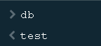

**Create database**

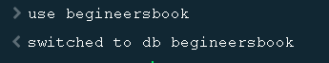

**Insert document in database**

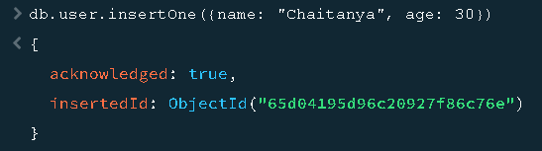

**Create collection and show collecrtions**

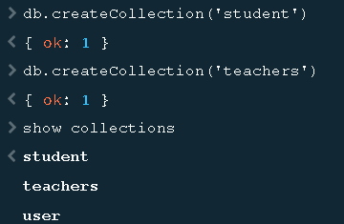

**Drop collection**

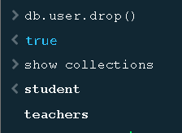

**Insert record in database and verify**

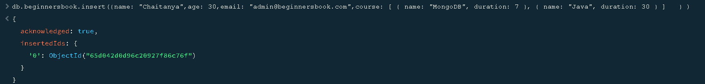

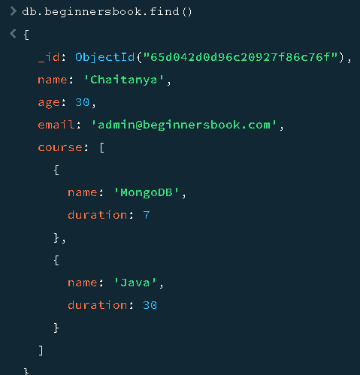

**Insert multiple document at once**

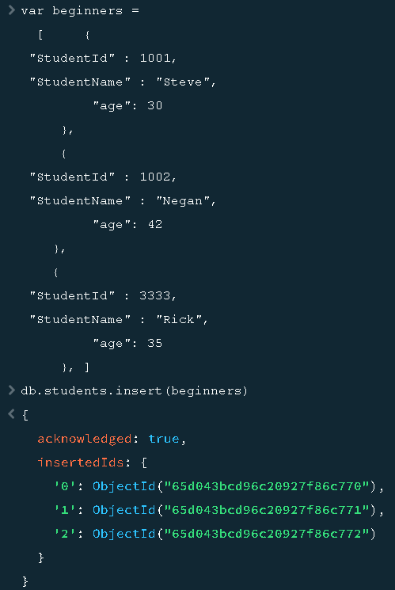

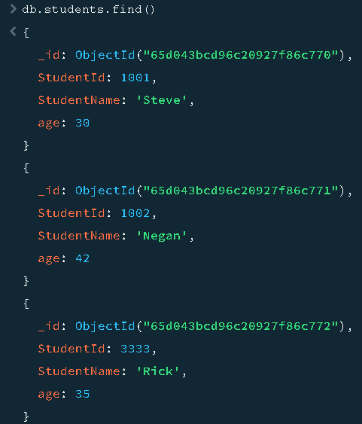

**Finding document with filter**

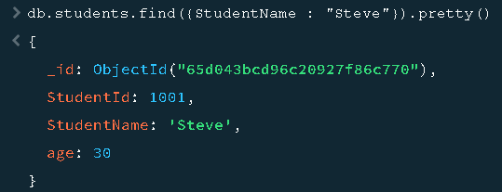

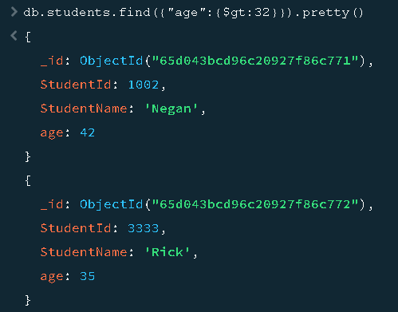

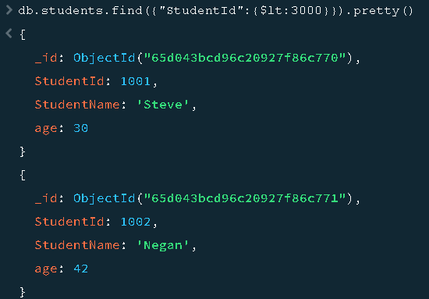

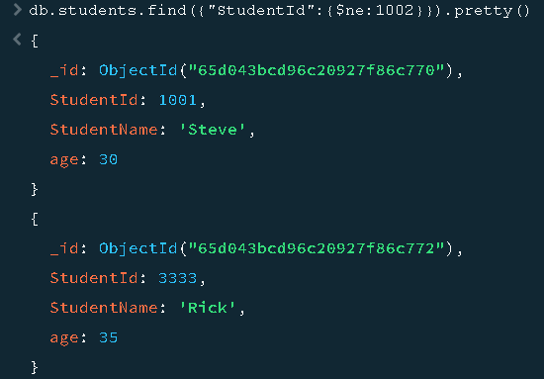

**Update document**

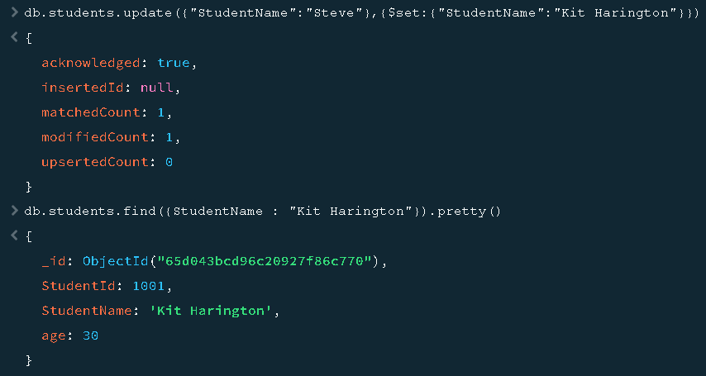

**Delete document**

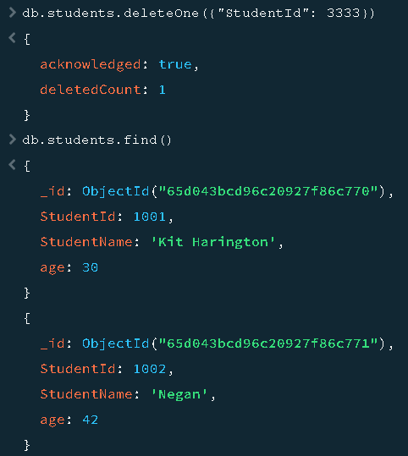

**Finding with Limit()**

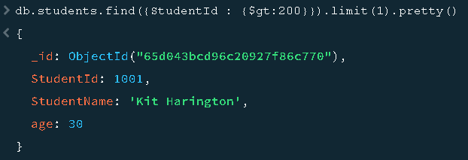

**Finding with skip()**

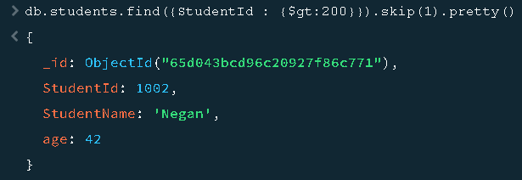

**Sorting (ascending and descending)**

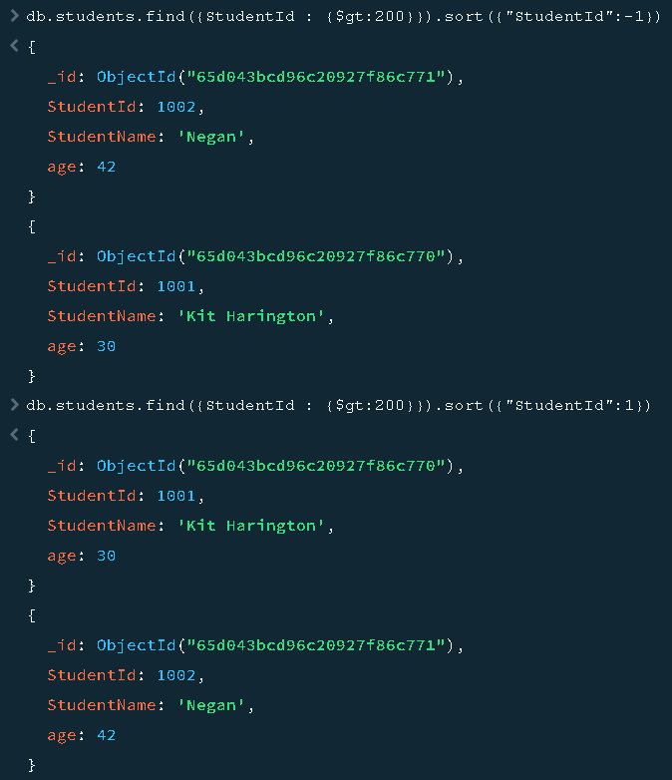

**Indexing**

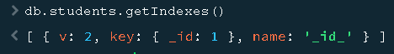

**Drop Collection**



**Drop database**

